

This Pretest is to be completed as preparation for the Unit Test and will be graded as a section of this test.

Collaboration with classmates is permitted, but copying work is considered cheating and will result in a zero.

The use of class notes is not permitted to complete this assignment.

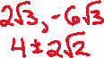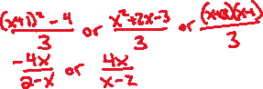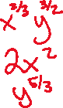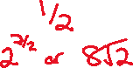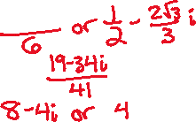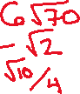

Quadratic Formula:

*x* = 

1. _________________
2. _________________
3. _________________
4. _________________
5. _________________
6. _________________
7. _________________
8. _________________
9. _________________
10. _________________
11. _________________
12. _________________
13. _________________
14. _________________
15. _________________
16. _________________
17. *x* = ______________
18. *x* = ______________
19. *x* = ______________
20. *x* = ______________
21. Fully simplify the radical expression: 
22. Fully simplify the radical expression: 
23. Fully simplify the radical expression: 
24. Fully simplify the radical expression: 
25. Write the complex number in standard form: 
26. Write the complex number in standard form: 
27. Fully simplify the expression: 
28. Fully simplify the expression: 
29. Fully simplify the expression: 
30. Fully simplify the expression: 
31. Fully simplify the expression: 
32. Fully simplify the expression: 
33. Fully simplify the expression: 
34. Fully simplify the expression: 
35. Calculate the inverse of the equation: 
36. Calculate the inverse of the equation: 
37. Solve the equation for all values of *x*: 
38. Solve the equation for all values of *x*: 
39. Solve the equation for all values of *x*: 
40. Solve the equation for all values of *x*: 